📍〰️🚩 Report: Maze Solver with Recursion

MADE BY:

Syed Zulqarnain Haider

📑 Table of Contents
- ❓ Problem Statement
- 🎯 Objectives
- 📖 Project Overview
- ⚙️ Code Logic and Implementation
  - 🌐 A. Global Variables
  - 📂 B. Menu and File Handling
  - 📍 C. Coordinate scanning
  - 🔄 D. Recursive Pathfinding
  - 🎨 E. Output & Visualization
- 🛠️ Tools Used
- 📊 Flow chart

1. ❓Problem Statement
In the field of computer science, pathfinding is a fundamental problem used in robotics, GPS navigation, and game development. A maze consists of walls (#) and open paths, and the challenge is to determine a valid route from a specific Start (S) point to an Exit (E) point without crossing walls.
The problem addressed in this project is to develop a C++ program that automates this process. Instead of manual solving, the program must intelligently explore the grid using recursion, identify the correct path, and utilize backtracking to recover from dead ends.

2. 🎯Objectives
The primary objectives of this lab project are:
- ✅ To implement File Handling to read maze layouts dynamically from a text file (input.txt)
- ✅ To utilize Recursion to navigate through the 2D grid.
- ✅ To apply Backtracking logic to handle dead ends and find the correct path.
- ✅ To display the final solution visually in the console using ANSI/Windows colors and save the result to output.txt.
- ✅ To generate a trace log (trace.txt) that records the recursive flow for debugging and analysis.

3. 📖 Project overview

This Project is a console-based application written in C++. It allows the user to load maze from a default file or a custom file. The maze is stored in 2D character array. The program finds the starting coordinated and initiates a recursive function find_path. This function marks the path with asterisks ( * ) and explores four direction (Right, Down, Left, Up). If the exit is found, the path is highlighted in Green. If path is blocked, the algorithm backtracks.

4. ⚙️ Code Logic and Implementation
🌐A. Global Variables and Setup

To ensure efficient memory access across recursive calls without passing heavy data structures, we utilized global variables:

- 📦 char maze_arr[100][100]: A static 2D array to hold the maze grid.
- 📏 int Rows, Cols: Dynamic counters to store the actual size of the loaded maze.
- 📍 start_Row, start_Col: To store the coordinates of ‘S’.
- 🔢 total_steps: An integer to count the total number of recursive calls.

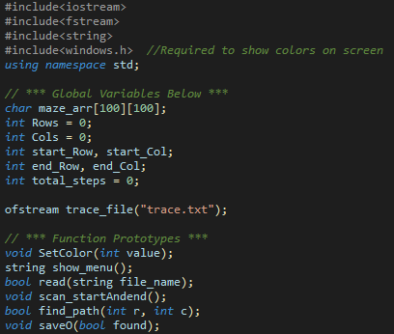

📂 B. Menu and File Handling (Input)

The program begins by offering a menu (implemented in show_menu()) allowing the user to choose between the default input.txt or a custom file.

The read(string file_name) function opens the file and reads it line-by-line using getline.

- 🚫 Space Handling: The code includes specific logic to ignore spaces, tabs, and carriage returns (if(letter != ' '...)), ensuring only valid maze characters are stored.
- 📐 Dynamic Sizing: The Rows and Cols variables are updated automatically based on the file content.
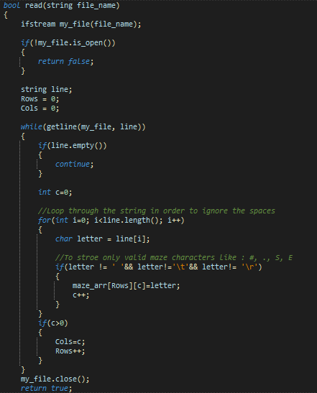

📍 C. Coordinate scanning
Before starting the recursion, the scan_startAndend() function iterates through the populated 2D array.
- 🔎 It searches for the character 'S' to set the starting point.
- 🏁 It searches for 'E' to confirm the exit location.
🔄 D. Recursive Pathfinding (find_path)
1. 🛑 Base Cases (Stopping Conditions):
- Boundary Check: If r or c are outside the matrix limits, return false.
- Obstacle Check: If the cell is a Wall ( # ) or already part of the current path ( * ), return false.
- Success: If the cell contains ‘E’. log the success to trace.txt and return true.
2. 👣 Recursive Steps:
- The Current cell is temporarily marked with * to indicate it is being visited.
- The function recursively calls itself in the following order:
  - ➡️ Right (c+1)
  - ⬇️ Down (r+1)
  - ⬅️ Left (c-1)
  - ⬆️ Up (r-1)
- If any of these return true, the function propagates true up the stack.
3. 🔙 Backtracking:
- If all four directions return false (meaning dead end), the function performs backtracking.
- It restores the cell to its original state using the temp variable (maze_arr[r][c]= temp).
- It logs the backtracking action to trace.txt.
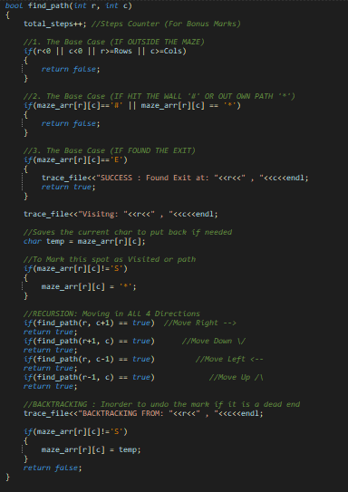

🎨 E. Output and Visualization
The saveO (bool found) function handles the final display.
- 🖥️ Console Output: It iterates through the grid. We utilized the windows.h library and SetConsoleTextAttribute to print the path ( * ) and success messages in Green (color code 10) and Errors in Red (Color code 12).
- 💾 File Output: The solved maze is simultaneously written to output.txt as required.
- 📝 Trace Log: Throughout the execution, steps are recorded in trace.txt.

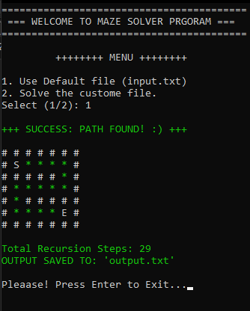

5. 🛠️Tools Used
• 💻 Language: C++ (CORE LOGIC)
• ⌨️ IDE: Dev-C++
• 📚 Libraries:
- <iostream> & <fstream>: For input/output and file operations.
- <windows.h>: For coloring the console output.
- <string>: For file name manipulation.
• 📉 Diagramming: Mermai.js for flowchart.

6. 📊 Flow Chart

Below is the flowchart representing the logic of the find_path function used in out project.

